Regnumator - Your secret friend 27th June 2023
By Dimitrii Borodinskii

There are some nice little bits built into the Regnumator built in for Landed B&B’s for Lochac which can help to keep track of your group and especially when it’s reporting time.

Once you log in at SCA Australia Ltd - Membership Services or the New Zealand equivalent, you will see a page similar to the one below. The main difference for Landed B&B’s is that middle entry “As a member of the gentry, you are able to see the warrants of the officers in your group.”

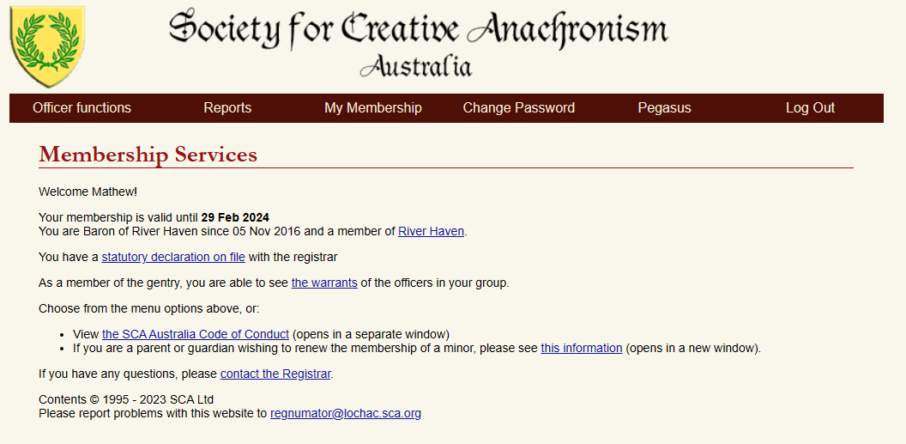

Clicking on “the warrants” link will take you to the officers within your Barony, including those of any Cantons or Colleges your Barony might have. We can see all the details of their appointments. The difference between your access as B&B and that of a Seneschal is that you have Read Only access, whereas a Seneschal can make changes.
Basically… look, no touchie.

You can also get the membership details for your Barony as well, quite useful for those pesky Doomsday reports.

Obviously from there, you can navigate through the second layer of menus and look at Reports for membership graphs or do a search on the member list for your group - not to mention update the details of your own Warrant (which is fine, changes will be saved).

There’s also the Appointinator section which you can play with… but that Read Only access thing really means nothing will happen… so might as well skip that section as it’s just a tease for us.

For general assistance about using the Regnumator, check out this handy user guide:
Regnumator User Guide | Lochac Seneschallate

